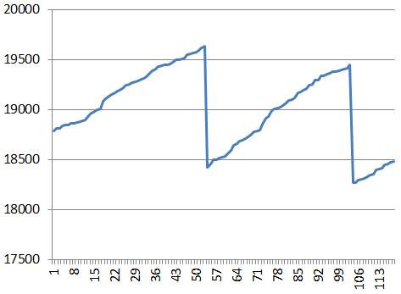
“…this system’s never going to work!”
“…geez, I’m glad I stuck it out.”

